Questions for Privacy Center SDE Candidates

Summary

This document contains a list of coding questions that must be answered by candidates applying for SDE positions.

You need to return the following to be considered for interview:

- A copy of this document with the answer for Question 1.

- A zip file with the source code with the solution for question 2. The source code must be written in C# and must include passing unit tests. Please, make sure to delete the generated binaries before zipping the solution as the binaries are not needed.

Question 1

You have the CarSales that contains the information about car sales from a car dealer. It has the columns [CarMaker, CarModel, SalePriceInDollar, SaleDate]. Write a SQL query to get the total sale price per maker and model from the past 30 days.

Result Example:

CarMaker | CarModel | TotalSalePrice
Maker A | A Model X V6 | 100,000
Maker B | B Model Z V6 | 200,000
Maker C | C Model Y 4000 | 100,000

Answer:

select

CarMaker,
CarModel,
SUM(SalePriceInDollar) as TotalSalePrice,
SaleDate

from

CarSales

WHERE SaleDate >= cast (getdate () - 30 as date) and SaleDate <= cast(getdate () as date)

group by CarMaker, CarModel, SaleDate
Question 2

Scenario:

Develop a .NET library assembly (DLL) for a system that handles the employee hierarchy, implemented as class Employees. This class has a constructor that takes a CSV string that contains all the employees from the company, the manager they report to, and the employee’s salary. Develop the library assembly that contains the code for the questions below. Make sure to provide unit tests for your code and an efficient solution.

- Create a constructor that takes a CSV¹ input string containing a list of employee info and validates the string. The first CSV column contains the id of the employee, the second one contains the id of the manager, and the third one contains the employee’s salary. The CEO of the company is the only employee that doesn't have a manager; in his case, the manager field will be empty. The list is not guaranteed to be sorted and can come in any random order. See the example below.


Example of CSV:

Emplyee4, Employee2,500 Employee3, Employee1,800 Employee1,,1000 Employee5,Employee1,500 Employee2,Employee1,500

Employee1

Employee2 Employee3 _{Employee5}

Employee4

The constructor should validate that:

  - The salaries in the CSV are valid integer numbers.

  - One employee does not report to more than one manager.

  - There is only one CEO, i.e. only one employee with no manager.

  - There is no circular reference, i.e., a first employee reporting to a second employee that is also under the first employee.

  - There is no manager that is not an employee, i.e., all managers are also listed in the employee column.

- Add an instance method that returns the salary budget from the specified manager. The salary budget from a manager is defined as the sum of the salaries of all the employees reporting (directly or indirectly) to a specified manager, plus the salary of the manager. See the example below.

Input type: String

Return type: long

- In CSV (Comma Separated Values), each line corresponds to a row, and columns are separated by a comma.

Input: Employee2

Result: 1800

Input: Employee3

Result: 500

Input: Employee1

Result: 3800

Employee1

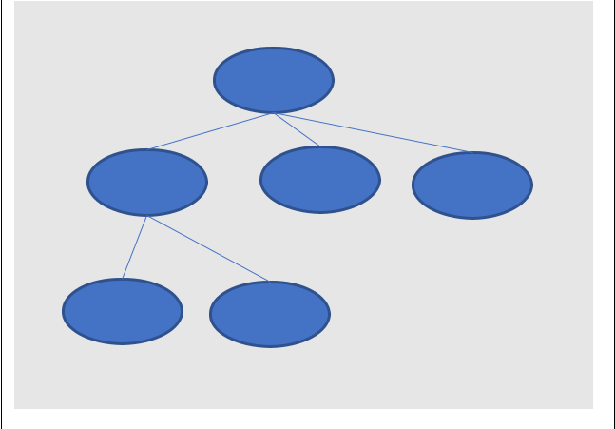
$1000

Employee2 Employee3 Employee5

$800 $500 $500

Employee4 Employee6

$500 $500

